**Instruction:** Answer **all** questions in question paper. (98 Marks)

The coronavirus disease 19 (COVID-19) is rapidly spreading across the world. Pharmacy services play a vital role in public health in preventing and containing the COVID-19 pandemic. All over the world, especially in the developed countries pharmacists have responded smartly and speedily for public health, such as establishing professional protective and service guidance for pharmacy staff and services, creating and updating drug formularies, addressing the issues of drug shortages, providing public education for prevention and management of infection, contributing in drug evaluation and clinical trials.

(Source: Hussain, K., Ambreen, G., Muzammil, M., Raza, S. & Ali, U. (2020). Pharmacy services during COVID-19 pandemic: experience from a tertiary care teaching hospital in Pakistan. J Pharm Policy Pract,13(1):74. Published 2020 Nov 2. doi:10.1186/s40545-020-00277-5)

Due to the importance of pharmacy service as stated by Hussain, et. al. (2020), you have taken the initiative to develop a database system related to pharmacy environment. You must follow the following task for your Pharmacy Database System.

**Task:**

1. **Database Design**

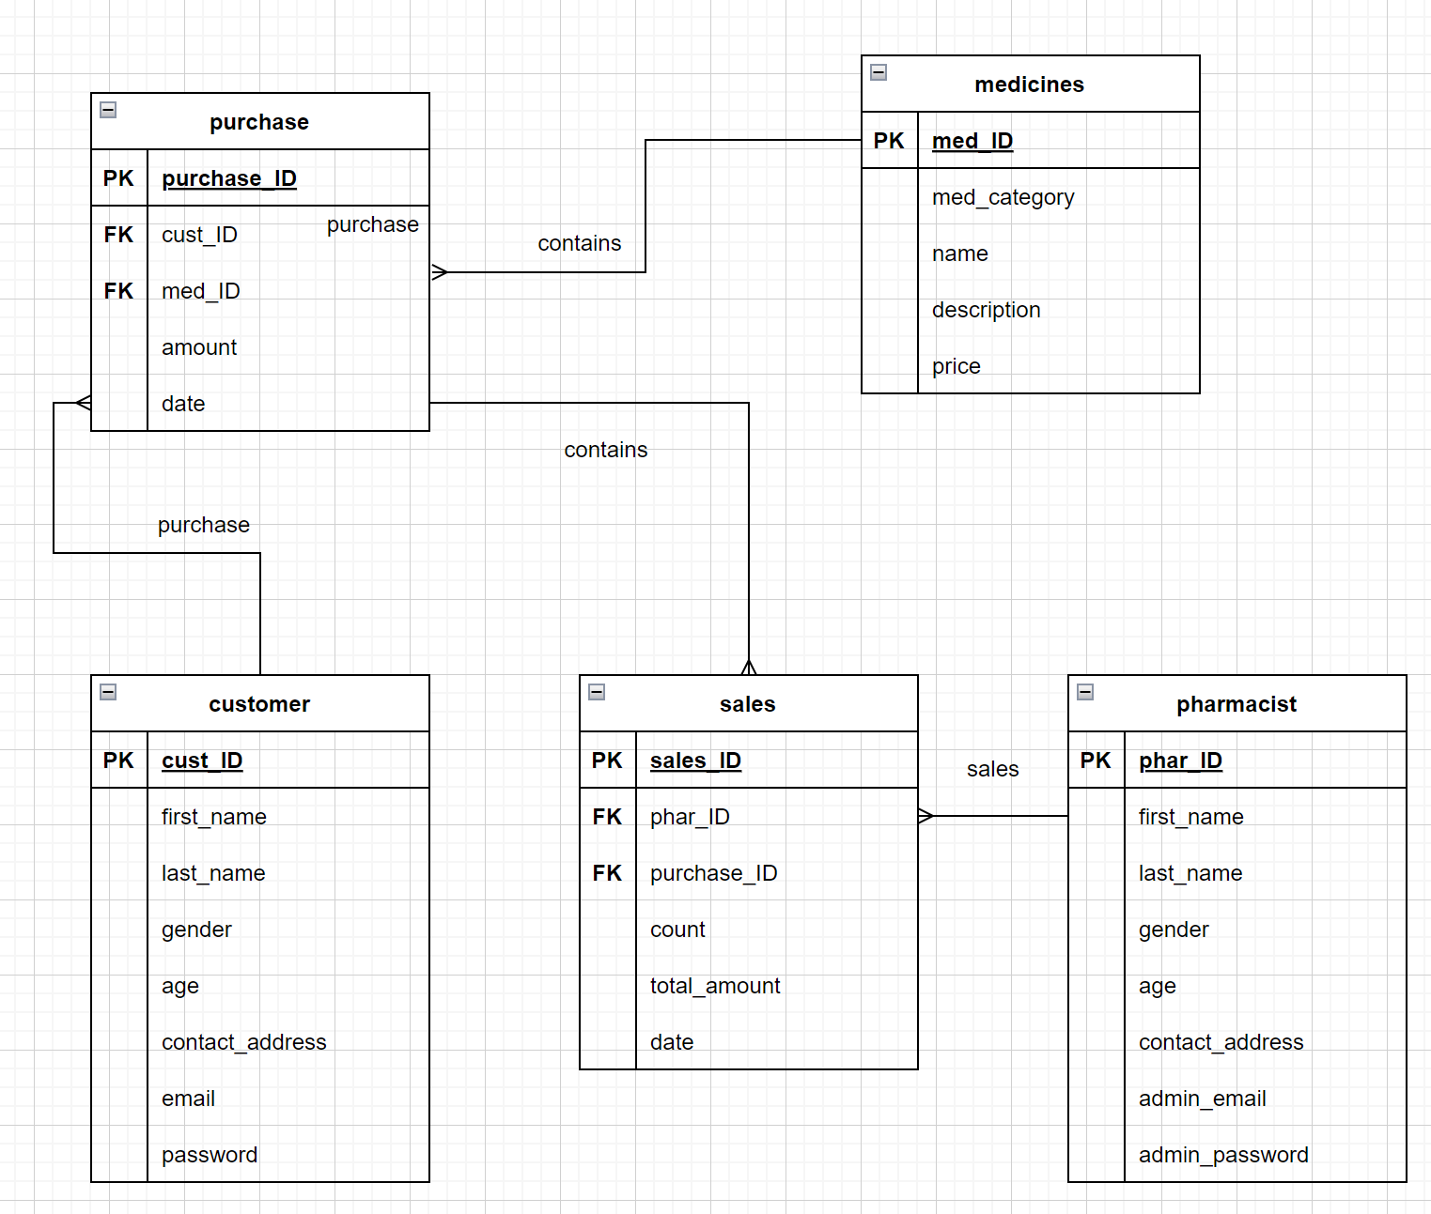

Create **one (1)** Entity Relationship Diagram (ERD) that consists of:

* At least **five (5)** entities
* At least **five (5)** attributes for each entity
* Primary keys and foreign keys
* Relationship names, cardinality and optionality

**[20.5 marks]**

1. **Database Development**

Based on the answer from task 1. Database Design above, develop the database using any Database Management System (DBMS), you must follow the following activities for your database development process.

**Activity A – SQL - Data Definition Language**

1. Creating a Database.

|  |  |  |
| --- | --- | --- |
| **Database Name** | **SQL Statement** | **Output** |
| pharmacy | CREATE DATABASE pharmacy; |  |

**[2.5 marks]**

1. Creating Table.

|  |  |  |
| --- | --- | --- |
| **Tables Name** | **SQL Statement** | **Output** |
| customer | create table customer  (  cust_ID int not null  primary key,  first_name varchar(100) null,  last_name varchar(100) null,  gender int null,  age int null,  contact_address varchar(255) null,  email varchar(100) null,  password varchar(20) null  ); |  |
| pharmacist | create table pharmacist  (  phar_ID int not null  primary key,  first_name varchar(100) null,  last_name varchar(100) null,  gender int null,  age int null,  contact_address varchar(255) null,  admin_email varchar(100) null,  admin_password varchar(20) null  ); |  |
| medicines | create table medicines  (  med_ID int not null  primary key,  med_category varchar(30) null,  name varchar(30) null,  description varchar(255) null,  price double null  ); |  |
| purchase | create table purchase  (  purchase_ID int not null  primary key,  cust_ID int null,  med_ID int null,  amount int null,  date date null,  constraint purchase_customer_cust_ID_fk  foreign key (cust_ID) references pharmacy.customer (cust_ID),  constraint purchase_medicines_med_ID_fk  foreign key (med_ID) references pharmacy.medicines (med_ID)  ); |  |
| sales | create table sales  (  sales_ID int not null  primary key,  purchase_ID int null,  phar_ID int null,  count int null,  total_amount double null,  date date null,  constraint sales_pharmacist_phar_ID_fk  foreign key (phar_ID) references pharmacy.pharmacist (phar_ID),  constraint sales_purchase_purchase_ID_fk  foreign key (purchase_ID) references pharmacy.purchase (purchase_ID)  ); |  |

**[12.5 marks]**

**Activity B – SQL - Data Manipulation Language**

Based on the information from Activity A – SQL - Data Definition Language, perform the following activity:

1. Insert at least **two (2)** data for ALL tables that have been created in Activity A.

|  |  |  |
| --- | --- | --- |
| **Insert** | **SQL Statement** | **Output** |
| Customer | insert into customer(cust_ID, first_name, last_name, gender, age, contact_address, email, password) values(1, 'George', 'Johnson', 1, 30, '3559 Poling Farm Road', 'qacvqmnutm@iubridge.com', '123456');  insert into customer(cust_ID, first_name, last_name, gender, age, contact_address, email, password) values(2, 'Stephen', 'Curry', 1, 34, '4814 Bird Street', 'eqljrotagu@iubridge.com', '345678'); |  |
| pharmacist | insert into pharmacist(phar_ID, first_name, last_name, gender, age, contact_address, admin_email, admin_password) values(1, 'Larry', 'Jones', 1, 30, '345 Capitol Avenue', 'npsrvuywai@iubridge.com', '123456');  insert into pharmacist(phar_ID, first_name, last_name, gender, age, contact_address, admin_email, admin_password) values(2, 'Tim', 'Hardaway', 1, 30, '346 Capitol Avenue', 'acubwunxpp@iubridge.com', '123456'); |  |
| medicines | insert into medicines(med_ID, med_category, name, description, price) values(1, 'A', ' Absinthol', ' hemostasis', 100);  insert into medicines(med_ID, med_category, name, description, price) values(2, 'B', 'Ablukast', 'anti-allergy', 100); |  |
| purchase | insert into purchase(purchase_ID, cust_ID, med_ID, amount, date) values(1, 1, 1, 2, curdate());  insert into purchase(purchase_ID, cust_ID, med_ID, amount, date) values(2, 1, 2, 2, curdate()); |  |
| sales | insert into sales(sales_ID, purchase_ID, phar_ID, count, total_amount, date) values(1, 1, 1, 2, 200, curdate());  insert into sales(sales_ID, purchase_ID, phar_ID, count, total_amount, date) values(2, 1, 1, 2, 200, curdate()); |  |

**[12.5 marks]**

**Activity C – SQL – Select Statement**

Based on the information from your Activity A – SQL - Data Definition Language and Activity B – SQL - Data Manipulation Language, write a complete SQL statement and output for:

1. Write a SELECT statement to retrieve all columns and all rows from any table.

|  |  |  |
| --- | --- | --- |
| **Your requirement** | **SQL Statement** | **Output** |
| To retrieve all medicines from medicines table | SELECT * FROM medicines; |  |

**[2.5 marks]**

1. Write a SELECT statement to retrieve **two (2)** columns and all rows from any table.

|  |  |  |
| --- | --- | --- |
| **Your requirement** | **SQL Statement** | **Output** |
| To retrieve customer name from customer table | SELECT first_name,last_name FROM customer; |  |

**[2.5 marks]**

1. Write a SELECT statement that retrieve any **four (4)** columns from any **two (2)** tables.

|  |  |  |
| --- | --- | --- |
| **Your requirement** | **SQL Statement** | **Output** |
| Get a breakdown of the number and amount of medicines sold by a pharmacist | SELECT a.first_name,a.last_name,b.count,b.total_amount from pharmacist a,sales b where a.phar_ID=b.phar_ID; |  |

**[2.5 marks]**

1. Write SELECT statements that is used comparison operators.

|  |  |  |  |
| --- | --- | --- | --- |
| **Comparison Operators** | **Your requirement** | **SQL Statement** | **Output** |
| = equal to | Get customers whose age is equal to 30 | SELECT first_name,last_name,age from customer where age = 30; |  |
| > greater than | Acquire customers older than 30 | SELECT first_name,last_name,age from customer where age > 30; |  |
| >= greater than or equal to | Get customers who are 30 years or older | SELECT first_name,last_name,age from customer where age >= 30; |  |
| < less than | Acquire customers younger than 34 years old | SELECT first_name,last_name,age from customer where age < 34; |  |
| <= less than or equal to | Get customers whose age is less than or equal to 34 | SELECT first_name,last_name,age from customer where age <= 34; |  |
| BETWEEN … AND | Acquire customers between the ages of 30 and 40 | SELECT first_name,last_name,age from customer where age BETWEEN 30 AND 40; |  |
| IN | Get customers whose age is 30 and 40 | SELECT first_name,last_name,age from customer where age IN (30, 40); |  |
| LIKE | Get medicines whose names start with Ab | SELECT name,med_category,price FROM medicines WHERE name like 'Ab%'; |  |

**[20 marks]**

1. Write SELECT statements that is used logical operators.

|  |  |  |  |
| --- | --- | --- | --- |
| **Logical Operators** | **Your requirement** | **SQL Statement** | **Output** |
| AND | Get medicines whose name starts with Ab and whose category is A | SELECT name,med_category,price FROM medicines where name like 'Ab%' AND med_category='A'; |  |
| OR | Get drugs whose name starts with Ab or whose class is A | SELECT name,med_category,price FROM medicines where name like 'Ab%' OR med_category='A'; |  |
| NOT | Get medicines whose prices are not 10 and 20 | SELECT name,med_category,price FROM medicines where price NOT IN (10, 20); |  |

**[7.5 marks]**

1. Write a SELECT statement to sort data from **one (1)** column.

|  |  |  |
| --- | --- | --- |
| **Your requirement** | **SQL Statement** | **Output** |
| Pharmacists sorted by age from oldest to youngest | SELECT first_name,last_name,age from pharmacist ORDER BY age ASC; |  |

**[2.5 marks]**

1. Write a SELECT statement to sort data from **two (2)** columns.

|  |  |  |
| --- | --- | --- |
| **Your requirement** | **SQL Statement** | **Output** |
| Sort by count and total_amount respectively in sales table | SELECT * FROM `sales` ORDER BY count,total_amount ASC; |  |

**[2.5 marks]**

1. Write a SELECT statement to group data from any table.

|  |  |  |
| --- | --- | --- |
| **Your requirement** | **SQL Statement** | **Output** |
| medicines grouped by category | SELECT COUNT(1), med_category FROM medicines GROUP BY med_category; |  |

**[2.5 marks]**

1. Write SELECT statements that is used Multiple-Row Functions.

|  |  |  |  |
| --- | --- | --- | --- |
| **Multiple-Row Functions** | **Your requirement** | **SQL Statement** | **Output** |
| MAX | Get the oldest pharmacist | SELECT first_name,last_name,MAX(age) FROM pharmacist; |  |
| MIN | Get the youngest pharmacist | SELECT first_name,last_name,MIN(age) FROM pharmacist; |  |
| AVG | Get the average age of all pharmacists | SELECT AVG(age) FROM pharmacist; |  |

**[7.5 marks]**

END OF QUESTIONS